Template for Abstract Submissions

1.
Use the template on the next page to create your abstract.

Please do not modify the format specified in the template. Abstracts that do not match the required template will be returned to the authors for revision.

Images may be submitted in color but will be reproduced in black and white in the printed book of abstracts.

The abstract must fit on one page.

2.
Remove this instruction page and save the abstract as a Word document.

3.
Send the abstract to the organizers by e-mail to ms2021@uochb.cas.cz.

Centered Title with All Words Capitalized Except for Articles, Prepositions and Conjunctions

PresentingAuthor Full Name,ª Author Full Name,^{b} Author Full Name ^{c}

ª Institution, Address, Country. ^{b} Institution, Address, Country. ^{c} Institution, Address, Country.
E-mail: john.smith@example.com

The text of the presenter’s oral or poster presentation abstract must be single-spaced, fully justified, and written in 11 pt Arial or Helvetica font. The citations should be numbered as superscripts¹ and detailed using ACS format. Please do not modify the format specified in the template. The entire abstract is limited to one page.

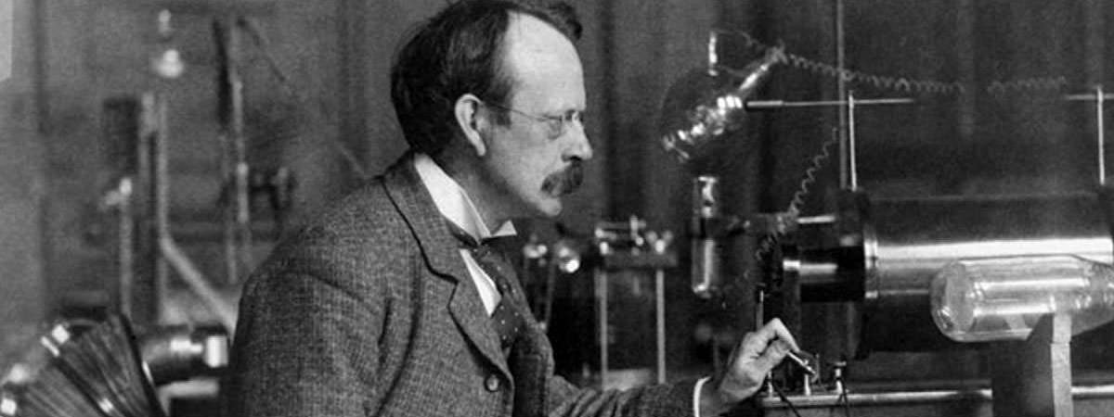

Figure 1. Figure caption. Delete this text box if not used.

References
¹ Lastname, H. A.; Lastname, A. J. MassSpec. Res. 2020, 6, 32-41.
² Author, A. B. In Book Title; Editor, C. D.; Ed.; Series Name and number; Publisher: City, STATE (2 letters) or Country, year; Vol. number, pp. xx-yy.

